**Practical Assignment: 5**

**Aim:** How to Process Raster in QGIS Layer Stacking (Composite), Mosaicking (Merge), and Clipping

**Theory:**

**Layer Stacking:**

Layer stacking, also known as compositing, involves combining multiple raster layers into a single layer. This is useful for:

- Creating false-color composites

- Combining multispectral or hyperspectral data

- Creating a single layer from multiple sources

**Mosaicking:**

Mosaicking, also known as merging, involves combining multiple raster layers into a single layer, often used for:

- Creating a seamless mosaic from multiple images or tiles

- Combining data from different sources

**Clipping :**

Clipping involves extracting a subset of a raster layer using a vector layer (e.g., polygon) as a mask.

Results:

Step 1: Open QGIS: Launch QGIS and load the raster layer

|  |  |
| --- | --- |
|  |  |

Step 2: Select Raster Layer: Select the raster layer and add the image

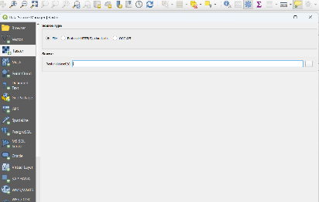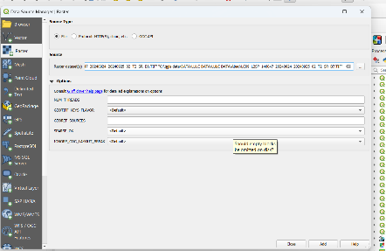

Step:3 select the addede image for stackking (Composite)

|  |  |
| --- | --- |
|  |  |

Step 4: select raster > miscellaneous and build virtual raster

|  |  |
| --- | --- |
|  |  |

Step 5: select the band for true to the staking data and after selecting band final result

|  |  |
| --- | --- |
|  |  |

Step 7: step for Mosaicking (Merge)

|  |  |
| --- | --- |
|  |  |

|  |  |  |
| --- | --- | --- |
| Step 8: result after Mosaicking | Step 9: process for clipping |  |

|  |  |
| --- | --- |
|  | Step 10 : Result after clipping |